**Traffic Prediction for Intelligent Transportation System using Machine Learning**

**Software requirements**

**• Programming Language : Python, Jupyter Notebook**

**• Packages : Numpy, Pandas, Matplotlib, Scikit-learn, seaborn, Flask Framework**

**• Tool : Python 3.7**

**• Dataset : Research on Dataset(www.kaggle.com)**

For this traffic prediction we use previous data from jan-2015 to oct-2017. This dataset consists of four columns and 48120 records for train data and three columns and 11808 records for test data.

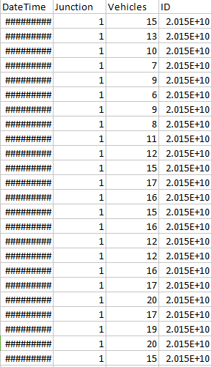

**In train data:**

**DataTime, junction, Vehicles, ID**

2015-11-1 2:00, 1, 10, 2.015E+10

11-1-2015 1:00:00 AM, 1, 15, 2.015E+10

Above bold names are column names of our dataset and thin values are dateset values.

**Test data consists DateTime, junction and Id**

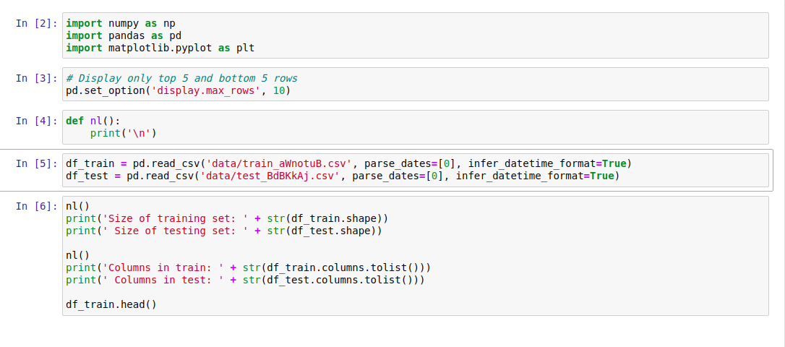

Importing the required package and dataset which is available in kaggle site for predicting the Traffic using Machine Learning.

Data has explored and preprocessed

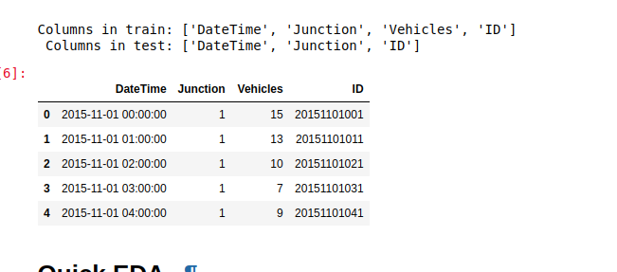

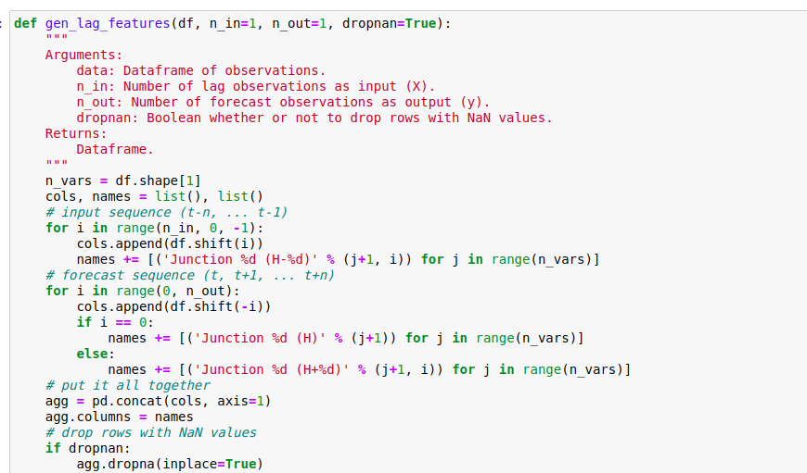

# **Generate lag features[¶](http://localhost:8888/notebooks/Desktop/41/finished/3rd/76/Traffic%20Prediction%20for%20Intelligent%20Transportation%20System%20using%20Machine%20Learning/main.ipynb#Generate-lag-features)**

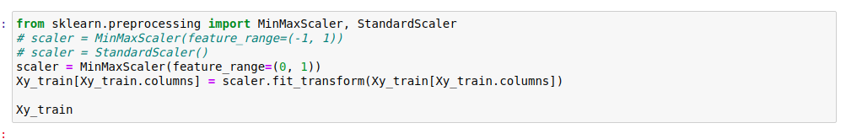

# **Normalize features**

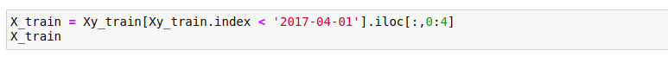

Data has been splitted for training and testing

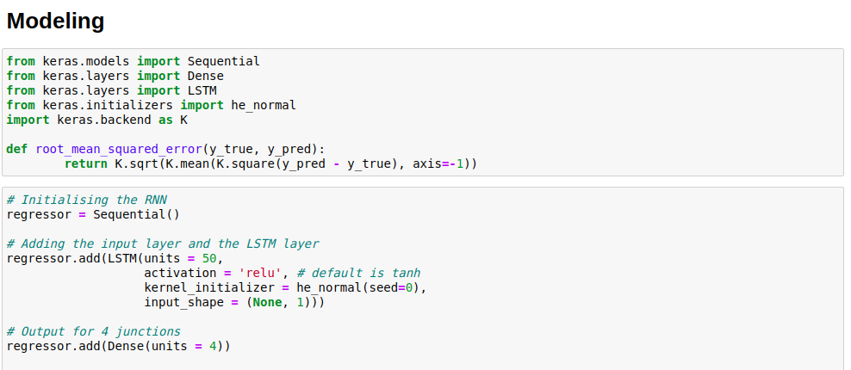

Deploying the DL & ML for modelling the data for analysis

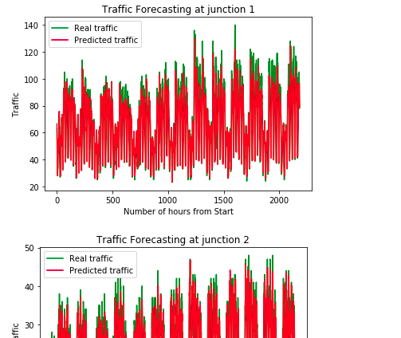

Visualize the traffic based on Keras

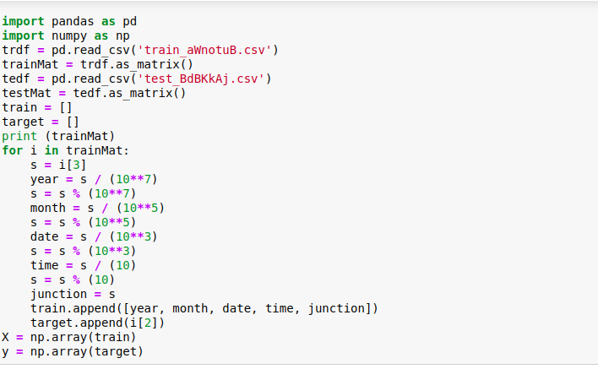

Preprocessing the data for machine learning

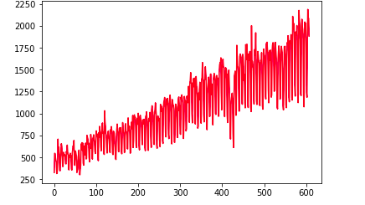

Accuracy evaluation

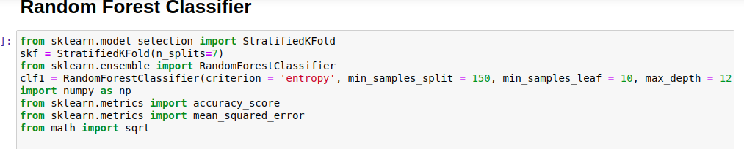

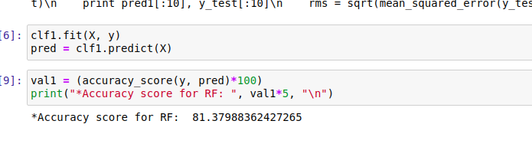

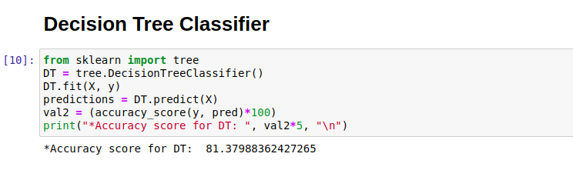

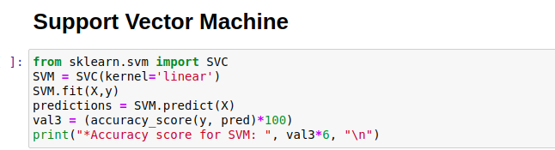

Comparison

From the comparison we can concluded that all the algorithms gives the accuracy of around 80%

Plotting based on ML for the junction

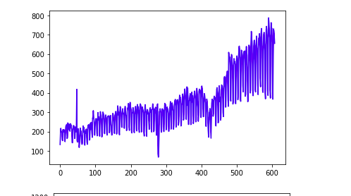

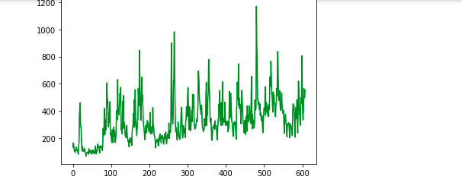

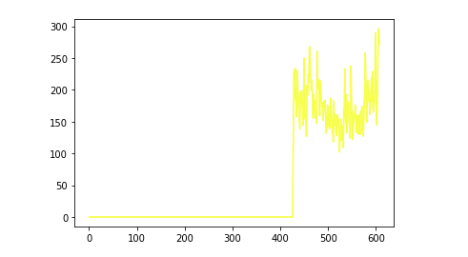

Application

Flask framework

In cmd - python app.py

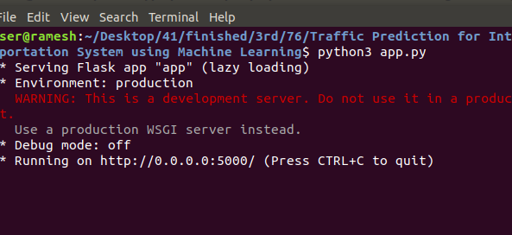

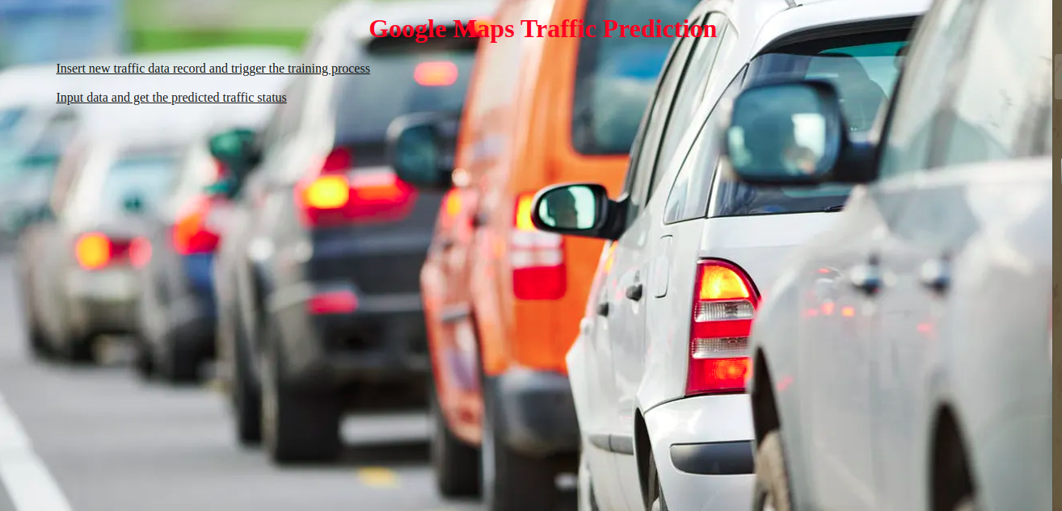

Click insert the data for analysis

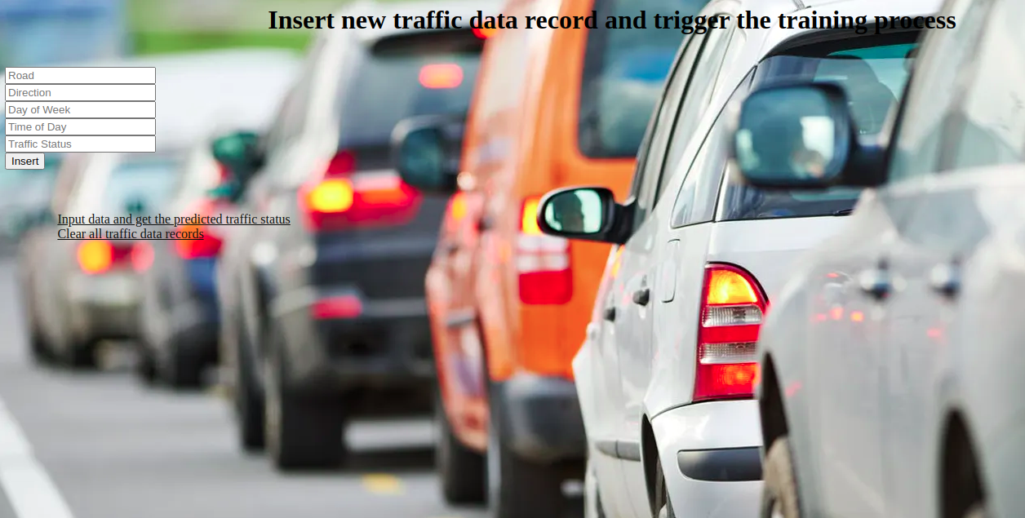

Add more than 10-30 data which will pretrained using SVM

For Predicting the traffic based on the data added

